**Bella beat Case Study: Fitbit Smart Device Data Analysis**

Jessica Nalli

Date: 26-08-2025

**Objective:**

To analyze user activity and sleep data to uncover patterns in engagement and wellness. The goal is to identify trends in daily usage, peak activity hours, and sleep quality, and to provide recommendations that can improve user habits and overall app engagement.

**Dataset:**

* The dataset used in this analysis comes from the FitBit Fitness Tracker Data available on Kaggle (CC0: Public Domain). It contains daily activity and health data collected from 30 eligible FitBit users who consented to share their information.
* The dataset spans March 2016 to May 2016 and includes detailed records of:
* Daily activity levels (steps, calories, distance)
* Sleep duration and time in bed
* Hourly activity intensity and patterns
* User-level daily summaries
* This dataset is used to understand general consumer smart device usage trends, which can then be applied to Bellabeat’s products and marketing strategy.

**Tools Used:**

* Excel (for exploration)
* SQL (for data cleaning)
* Tableau (for Visualization)

**Visualizations and Insights:**

Chart 1: Daily Active Users

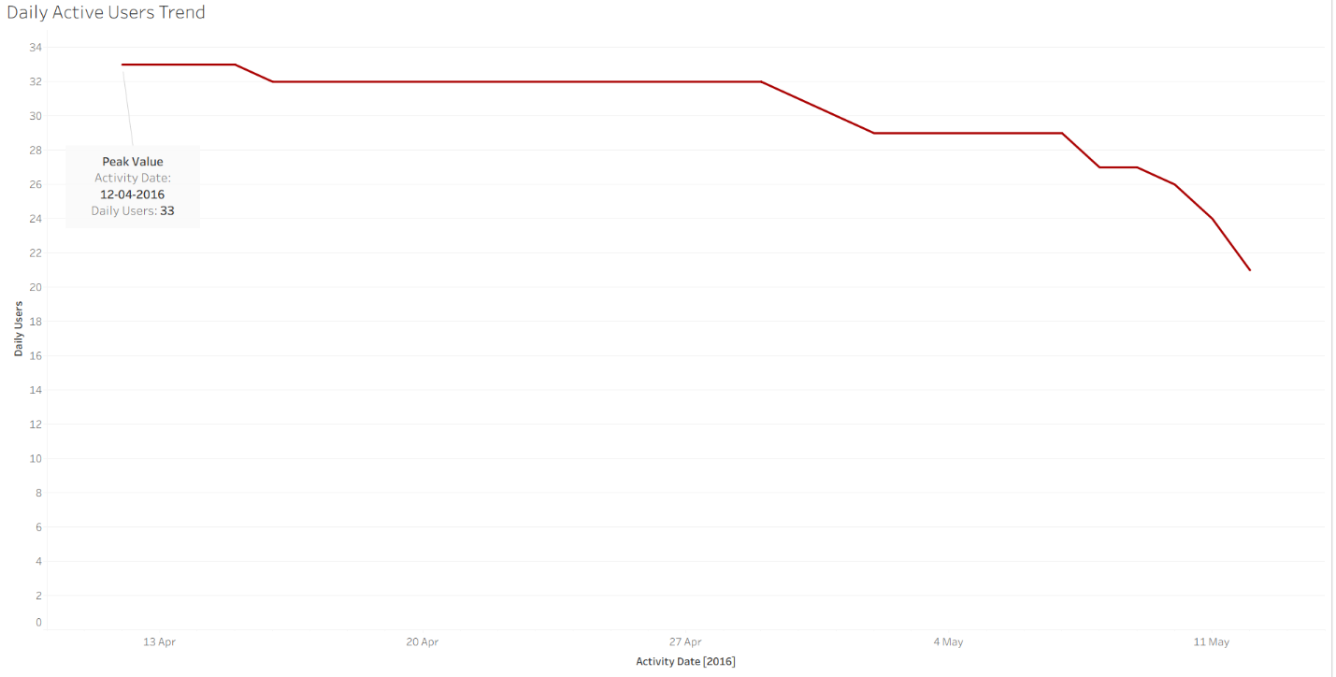

This line chart shows the daily active users over time, highlighting a peak in mid-April. This is a key metric for understanding user engagement. It directly reflects how engaged the users are with the app.

Chart 2: Peak Activity Hours

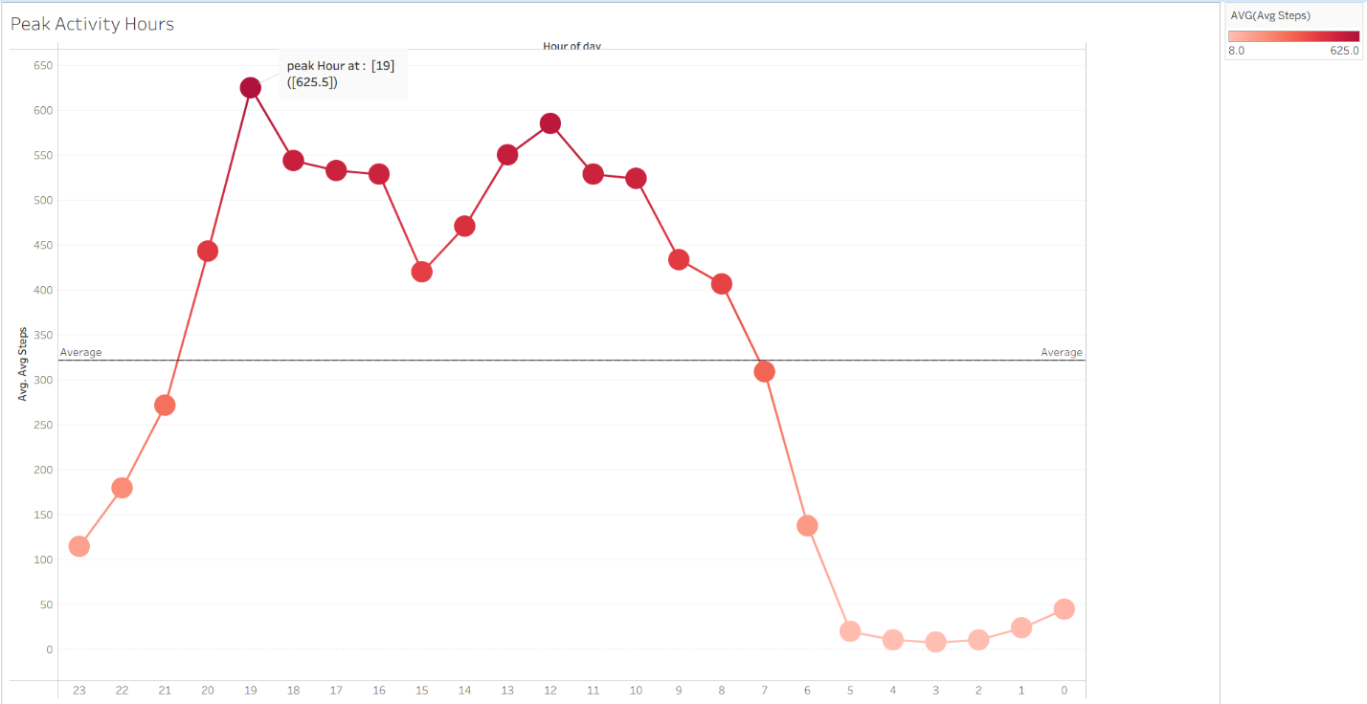

This Line chart shows a clear pattern of activity throughout the day, with peaks in the morning and evening.

User activity is low during early morning hours, rises steadily through the day, and reaches its highest point in the evening between 6–9 PM. This shows that evenings are the most active time for users.

Chart 3: Average Sleep duration

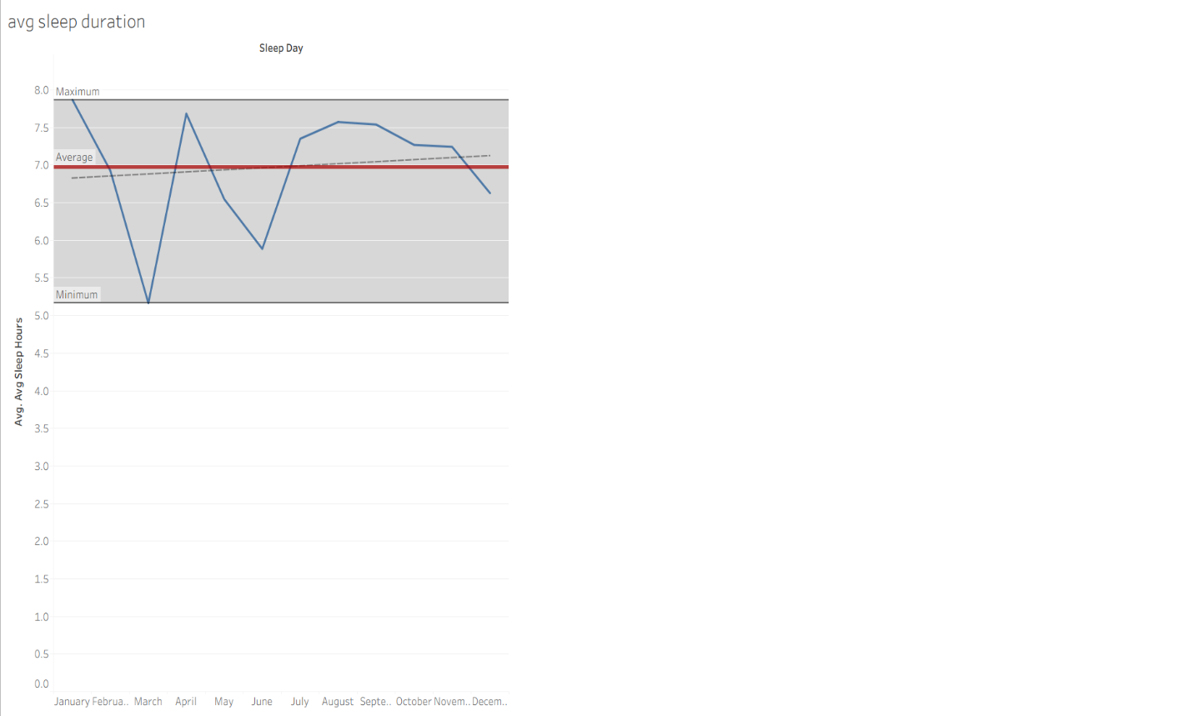

The chart shows the daily average sleep hours change from day to day.

The blue line tracks how average sleep hours change from day to day.

The red solid reference line represents the overall average sleep duration.

The dashed reference lines highlight the minimum observed values of sleep hours.

Chart 4: Monthly sleep patterns

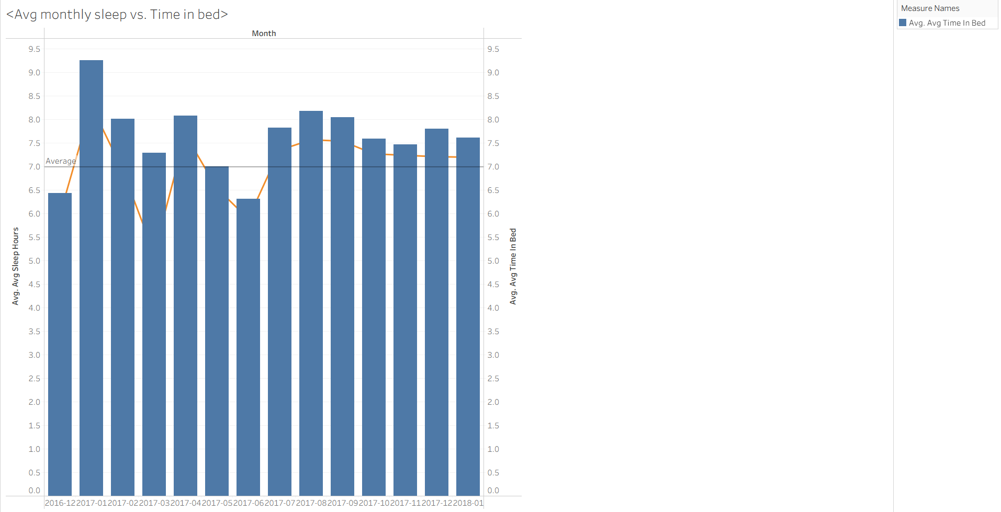

This chart shows a trend in sleep duration over several months.

The Avg sleep hours shows in bar chart. And Avg time in bed shows in Line chart.

On average, users spend more time in bed than the actual hours they sleep. This gap shows that users may not be sleeping efficiently and could experience restless or interrupted sleep.

Chart 5: Average daily steps by day of week

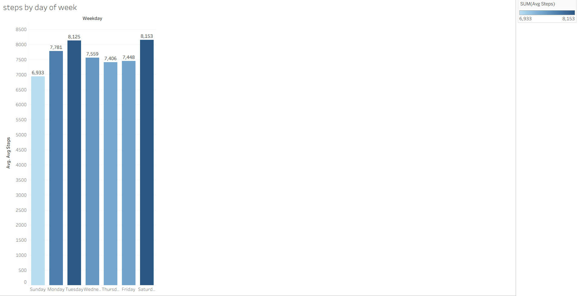

This chart explains the average number of steps users take on each day of the week. It is in Bar chart.

Activity levels fluctuate across the week, with the lowest steps recorded on Sundays(6,933) and the highest on Saturdays(8,153).

**Recommendations:**

* Encourage regular usage through reminders, notifications or scheduled challenges that motivates daily activity.
* Add short walks or stretching breaks in the morning and mid afternoon to reduce long sedentary periods.
* If possible maintain some level of activity earlier in the day to build a steadier rhythm rather than concentrating more steps in the evening.
* Avoid late night screening time, irregular work hours. And aim for a consistent sleep routine.
* Promote sleep quality, not just time in bed.
* To improve overall sleep health, interventions should focus on enhancing sleep quality, reducing disturbances and promoting consistent sleep habits across months, especially during periods with lower averages.
* Focus on boosting activity on low steps days throughout targeted challenges, reminders or community engagement while building on Saturday’s momentum to maximize overall weekly step counts.

**Conclusion:**

Overall, the analysis shows that user engagement and wellness can be strengthened by focusing on consistent activity, improved sleep quality, and targeted app features. Implementing these recommendations will not only help users build healthier habits but also enhance long-term engagement with the app.